COURSE WORK DOCUMENTATION
Sports Events Application – Database & Analytics
1. Common Information
Goal: Develop a complete data solution for a Sports Events Application, including OLTP database, OLAP data warehouse, ETL processes, analytical reporting, and documentation.
Required Skills: Relational database design, SQL, ETL, data warehousing, dimensional modeling, Power BI.
Deliverables:
- OLTP schema
- CSV datasets
- Staging schema
- ETL OLTP loading
- OLAP (DWH) schema
- ETL OLTP → DWH
- Power BI report
- SQL analytical queries
- Documentation
- GitHub repository
2. Course Work Statement
The project includes:
- Designing an OLTP relational database
- Preparing CSV datasets and loading them into OLTP
- Designing an OLAP analytical database (DWH)
- Implementing ETL from OLTP to OLAP
- Creating a Power BI report
- Writing OLTP and OLAP analytical queries
- Documenting the entire solution
- Publishing all components to GitHub
3. Course Work Overview
The Sports Events Application manages:
- Users
- Teams
- Team membership
- Sports
- Locations
- Events
- Registrations
- Payments
- Reviews
The analytical component answers:
- Revenue by sport
- Participation trends
- Geographic distribution of participants
- Team composition history (SCD2)
4. OLTP Database
4.1 OLTP Context — What We Store
The OLTP database supports the operational part of the application:
- Users register and participate in events
- Teams are created by users
- TeamMembers tracks which users belong to which teams
- Sports define event categories
- Locations define where events take place
- Events are created for specific sports and locations
- Registrations represent team participation
- Payments represent event entry fees
- Reviews allow users to leave feedback
This is a fully normalized (3NF) transactional model.
4.2 OLTP Logical Schema (ER Diagram)
The OLTP ERD includes all entities, primary keys, foreign keys, and relationships. Diagram is stored in GitHub:
also picture :
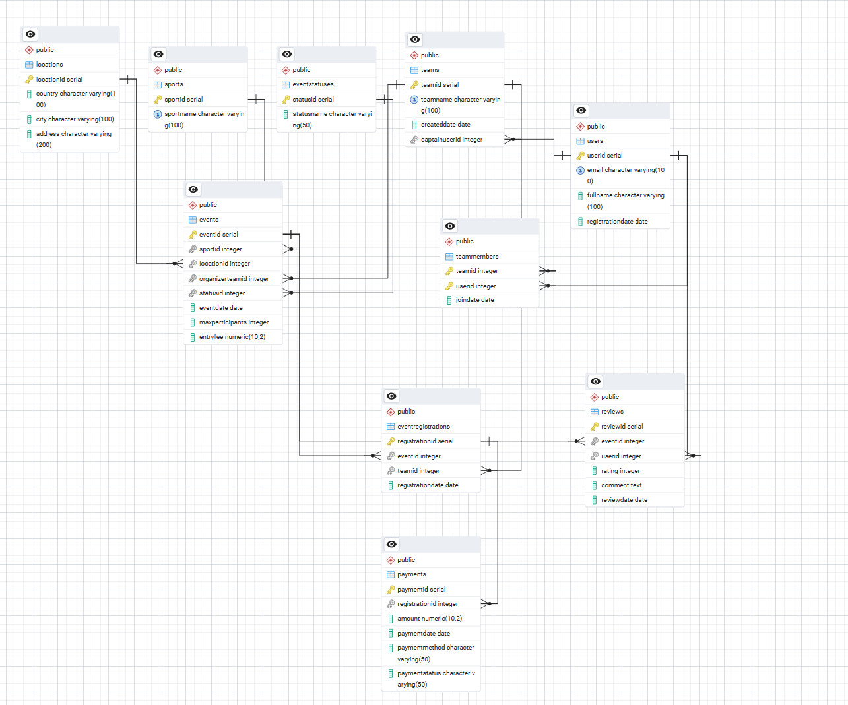
4.3 OLTP Tables Description
Users
- UserID (PK)
- Email (UNIQUE, NOT NULL)
- FullName
- RegistrationDate
Teams
- TeamID (PK)
- TeamName (UNIQUE)
- CreatedDate
- CaptainUserID (FK → Users)
TeamMembers
- TeamID (FK → Teams)
- UserID (FK → Users)
- JoinDate
- PK = (TeamID, UserID)
Sports
- SportID (PK)
- SportName (UNIQUE)
Locations
- LocationID (PK)
- Country
- City
- Address
EventStatuses
- StatusID (PK)
- StatusName
Events
- EventID (PK)
- SportID (FK)
- LocationID (FK)
- OrganizerTeamID (FK)
- StatusID (FK)
- EventDate
- MaxParticipants
- EntryFee
EventRegistrations
- RegistrationID (PK)
- EventID (FK)
- TeamID (FK)
- RegistrationDate
Payments
- PaymentID (PK)
- RegistrationID (FK)
- Amount
- PaymentDate
- PaymentMethod
- PaymentStatus
Reviews
- ReviewID (PK)
- EventID (FK)
- UserID (FK)
- Rating (CHECK 1–5)
- Comment
- ReviewDate
4.4 CSV Data Preparation
CSV files were prepared for:
- users
- teams
- team_members
- sports
- locations
- events
- registrations
- payments
- reviews
All CSV files contain no surrogate keys. All data types match OLTP table definitions.
4.5 OLTP Load Script (CSV → STAGING → OLTP)
The loading pipeline:
- CSV files are imported into staging schema
- Staging tables are cleaned:
  - duplicates removed
  - invalid FK removed
  - empty rows removed
- UPSERT logic loads data into OLTP:
  - new rows inserted
  - changed rows updated
  - unchanged rows ignored
- Script is fully rerunnable
This satisfies the requirement:
Script should be rerunnable and must not overwrite unchanged data.
5. OLAP Database (DWH)
5.1 OLAP Context — Analytical Questions
The DWH answers:
- Which sports generate the most revenue
- How participation changes by month
- Which countries have the most participants
- How team composition changes over time (SCD2)
5.2 OLAP Logical Schema (Snowflake Model)
Stored in GitHub:
also picture:
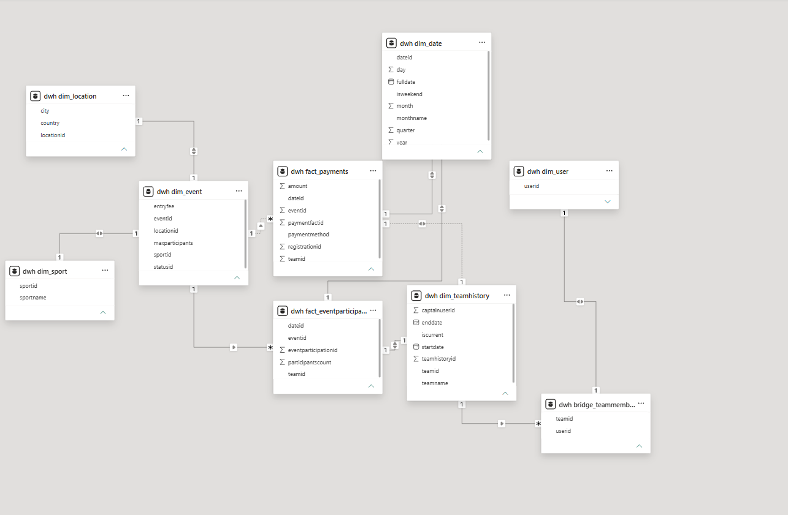
5.3 OLAP Tables Description
Dimensions
- Dim_Date — calendar dimension
- Dim_User — user attributes
- Dim_Sport — sport categories
- Dim_Location — geographic attributes
- Dim_Event — event metadata
- Dim_TeamHistory — SCD2 dimension tracking team changes
Bridge
- Bridge_TeamMembers — many-to-many relationship between teams and users
Facts
- Fact_EventParticipation — participation metrics
- Fact_Payments — revenue metrics
5.4 SCD Type 2 Implementation
Dim_TeamHistory tracks historical changes:
- When TeamName or CaptainUserID changes:
  - old record is closed (EndDate set, IsCurrent = FALSE)
  - new record is inserted with StartDate = CURRENT_DATE
This preserves full team history.
5.5 OLAP vs OLTP Differences
Feature | OLTP | OLAP
Purpose | Transactions | Analytics
Model | 3NF | Snowflake
History | No | Yes (SCD2)
Aggregations | No | Yes
Keys | Natural | Surrogate + business keys
6. ETL Process
6.1 ETL Overview
Pipeline:
- Extract data from OLTP
- Validate and transform
- Load into OLAP
6.2 ETL Logic
- Dimensions loaded first
- SCD2 applied to Dim_TeamHistory
- Bridge table updated
- Facts loaded last
- Only new data inserted
- Existing data not overwritten
- Script is fully rerunnable
6.3 ETL Script Description
Loads:
- Dim_Date (generated)
- Dim_Sport
- Dim_Location
- Dim_User
- Dim_Event
- Dim_TeamHistory (SCD2)
- Bridge_TeamMembers
- Fact_EventParticipation
- Fact_Payments
All loads use:
- WHERE NOT EXISTS
- SCD2 update + insert
- DateID = YYYYMMDD
7. Power BI Report
7.1 Connection
Power BI connects to PostgreSQL → DWH schema.
7.2 Data Transformations
- Converted numeric types
- Cleaned nulls
- Renamed columns
- Ensured correct date formats
7.3 Visual Components
Title: Sports Events Analytics Dashboard
Slicers:
- Sport
- Year
Visuals:
- Bar Chart — Total revenue by sport
- Line Chart — Participation by month
- Map — Participants by country
7.4 Interpretation
- Football generates the highest revenue
- Participation peaks in May
- Most participants come from Lithuania
- Basketball shows moderate revenue
8. SQL Queries
8.1 OLTP Queries
Examples:
- Total payments per event
- List of teams with captains
- Events by sport and location
8.2 OLAP Queries
Examples:
- Revenue by sport
- Participation by month
- Participants by country
9. GitHub Repository Structure
Code
CourseWork_SQL/
│
├── CSV/
├── ERD/
├── OLTP Base/
├── OLAP Solution/
├── PowerBI Report/
├── Queries/
10. Conclusion
The project successfully implements:
- OLTP database
- OLAP data warehouse
- ETL pipeline
- Analytical Power BI dashboard
- SQL analytical queries
- Full documentation
The solution is complete, reproducible, and meets all course requirements.

